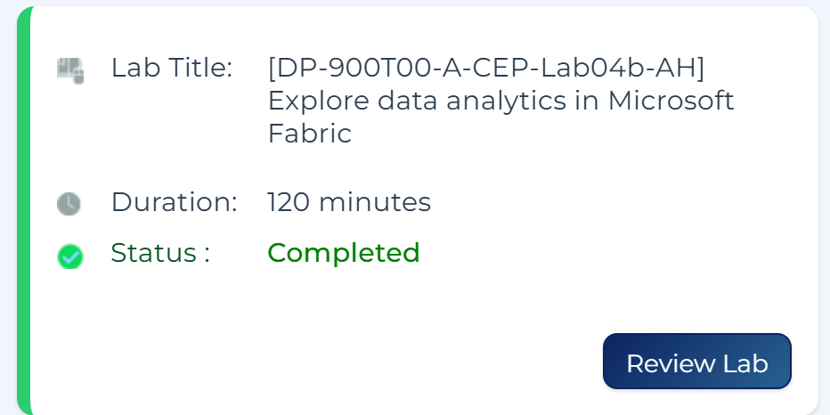

Data Technician Week 5
Workbook
Azure Data Fundamentals

Name:
Course Date:
Table of contents
Day 1: Task 1 3
Day 1: Task 2 4
Day 1: Task 3 5
Day 2: Task 1 6
Day 3: Task 1 10
Day 3: Task 2 11
Day 3: Task 3 12
Day 4: Task 1 13
Day 4: Task 2 14
1. Scenario Background 14
2. Data Laws and Regulations 14
3. Azure Service Recommendations 14
4. Data Types and Data Modelling 14
5. Data Storage Formats and Structures in Azure 15
6. Additional Considerations 15
Submission Guidelines: 15
Course Notes 18
Additional Information 19

Day 1: Task 1

Please research and complete the questions below relating to key concepts of cloud.

Be prepared to discuss the below in the group following this task.

What can cloud computing do for us in the real-world? | Apple for instants, uses cloud computing to run iCloud, its storage and sync service. It allows users back up photos, documents and settings, and access them across iPhone, iPad and Mac. Upload a photo from your iPhone and you can view it straight away on your MacBook.  Apple uses the system called AWS to support key services like iCloud, spending millions each month to ensure its systems run smoothly. This partnership allows Apple to keep innovating while benefiting from AWS’ scalability and reliability. Apple is one of AWS’ largest customers, which shows how crucial this collaboration is for both companies.  Sources:https://www.opsolutions.biz/aws-and-apple-a-powerful-collaboration-for-cloud-driven-innovation
How can it benefit a business? | Cost savings — Apple avoids building enough of its own data centres to serve billions of devices. It spends around $30 million a month renting Amazon's cloud instead, which is cheaper than owning that scale of infrastructure outright.  Sources: https://www.opsolutions.biz/aws-and-apple-a-powerful-collaboration-for-cloud-driven-innovation
What’s the alternative to cloud computing? | In house computing which sampling meaning manages its own physical servers on site,  Even Apple, despite relying heavily on AWS for iCloud, still runs some of its own data centres rather than using the cloud for everything  Sources : https://www.dell.com/en-us/lp/dt/on-premise-vs-cloud
What cloud providers can we use, what are their features and functions? | Amazon Web Services (AWS) — Apple's main cloud partner. uses for storing files, images and videos, accessible from anywhere. This is what Apple uses to hold encrypted chunks of iCloud dat  Google Cloud Platform (GCP)- Supports iCloud storage as a secondary cloud partner  Microsoft Azure — Apple previously used Azure alongside AWS and Google Cloud to store iCloud data, though later reporting suggests Apple moved away from it in favour of the other two.

Day 1: Task 2

Please research the below cloud offerings, explain what they are and provide Introduction to Microsoft Azure Data Core data concepts - Training | Microsoft Learn v
Do core concepts - 22min. Provide 40 mins to do this
examples of use cases.

Cloud Offerings | Explain what it is | When / how might you use this service in the real-world?
IaaS (Infrastructure as a service) | The provider looks after the physical equipment; you just pay for what you use. | A good real example is Apple. Even a company as big as Apple doesn't own enough data centres to handle iCloud on its own. Instead, it rents storage and computing capacity from AWS and Google Cloud, scaling up as more people sign up rather than constantly building new server rooms.
PaaS (Platform as a service) | This is a step up from IaaS(Infrastructure as a service), instead of just renting servers, you get a readymade platform to build and run applications on, so you don't have to worry about setting up operating systems yourself. | Apple has its own version of this aimed at developers, called CloudKit. It lets app developers store and sync their app's data through iCloud without having to build and manage their own backend servers or databases
SaaS (Software as a service) | This is the layer most people are familiar with, "I personally call this this the finished product" It's a finished software delivered over the internet, usually through an app or browser, where the provider handles everything behind the scenes. | iCloud itself is Apple's SaaS product. It lets me back up my photos and files and keep everything in sync across my devices and pick up exactly where I left off on a different device without managing anything myself.

Day 1: Task 3

Please research the below terms and explain what they are, when they would be appropriate and a real-world example of where it could be implemented (i.e. what type of organisation).

Public Cloud | Public Cloud is shared structure run by a provider like AWS or Google Cloud, used by many customers. Apple uses this for iCloud's less sensitive storage, avoiding the cost of building enough data centres for over a billion users that will cost them more than they are making.
Private Cloud | Private Cloud is dedicated system for one organisation, giving more control and security. (IN HOUSE CLOUD) Apple built Private Cloud Compute (PCC), its own network of Apple silicon servers, so that Apple Intelligence AI requests too complex for an iPhone can be processed without Apple, or anyone else, being able to read the data.
Hybrid Cloud | Hybrid Cloud mixes public and private. In 2026, Apple began running some Private Cloud Compute (PCC) workloads on Google Cloud hardware while keeping full control of the software, encryption and security rules, using public infrastructure without lowering its private cloud's privacy standards.
Community Cloud | Community Cloud is shared infrastructure for organisations with common needs, like NHS trusts sharing healthcare compliance standards. Apple doesn't fit this model itself  Sources:  https://security.apple.com/blog/expanding-pcc/  https://azure.microsoft.com/en-us/resources/cloud-computing-dictionary/what-are-private-public-hybrid-clouds  https://www.neowin.net/news/apple-is-expanding-private-cloud-compute-beyond-its-own-data-centers/

Day 2: Task 1

Describe, with examples, the three major areas that the Computer Misuse Act deals with. Cite your sources.

Area | Description | Example
Section 1  Unauthorised access to computer material | Covers unauthorised access to computer material or data, norally known as hacking | Guessing someone password and getting into their mobile phone without permission.  Source: https://uklawreference.com/legislation/computer-misuse-act-1990
Section 2 Unauthorised access with intent to commit further offences | Covers unauthorised access carried out with the intent to commit or help commit a further. | Accessing someone's online bank account intending to steal from it, even if you successfully do it or not you, you will be charged  Source:  https://www.legislation.gov.uk/ukpga/2015/9/notes/paragraph/126
Section 3  Unauthorised acts to impair the operation of a computer | unauthorised acts intended to impair a computer's operation. | Infecting a computer system with a virus that seriously damages system files  Source:  https://uklawreference.com/legislation/computer-misuse-act-1990

The Computer Misuse Act 1990 is an act under which an individual can be criminalised for a computer-related offence. Describe three extra powers that the Police and Justice Act 2006 (Computer Misuse) has added. (Cite sources)

Description
Longer sentences for hacking. The maximum jail term for basic hacking offences went up from five years to ten. This showed how much more seriously the courts started taking cybercrime since

Widened what counts as unauthorised access. The law was added so it's not just about someone accessing a system themselves in the moment, it’s also setting things up to access a system yourself later on.
Before 2006, it wasn't spelled out in law whether flooding a system with traffic to knock it offline, The 2006 Act fixed that grey area and made it an explicit offence.

Sources:
legislation.gov.uk — Police and Justice Act 2006, Section 35
Open Rights Group Wiki — Police and Justice Act 2006

Look at the website below to answer the questions:
https://www.gov.uk/personal-data-my-employer-can-keep-about-me

Write down three items of data which a company can store about an employee.
National Insurance number

tax code

emergency contact details

Give three more examples of data that an employer can only store if they first get the employee’s permission.
biometrics, for example if your fingerprints are used for identification

health and medical conditions

race and ethnicity

Conduct further research to answer the questions below. (Please do your fact-checking and cite sources.)

Question | Answer
Provide one example of: Copyright infringement | In 2007, Viacom sued YouTube for $1 billion for hosting over 150,000 unauthorised clips of Viacom's TV shows and other copyrighted content on its site.  Source: https://researchguides.dartmouth.edu/c.php?g=243675&p=9334983
Provide one example of: Plagiarism | In 2014, CNN dismissed a London-based news editor after uncovering 128 separate instances of plagiarism over six months, mostly copied from Reuters.  Source  https://ori.hhs.gov/copyright-infringement-fair-use-and-plagiarism
What are two consequences of copyright infringement and software piracy? | First will be under the Copyright, Designs and Patents Act 1988, infringement can lead to fines, damages owed to the copyright holder  Secondly infringement can harm the reputation of an individual or business, sometimes leading to a lasting loss of customers, investors or business partners.  Source: https://copyrightalliance.org/differences-copyright-infringement-plagiarism/  https://www.london-law.co.uk/breaching-copyright-criminal-offence/
Give three possible consequences for individuals when using pirated software | 1 Malware and security risks pirated versions often contain malware or spyware that can infect the user's device.  2 No updates or support pirated software usually can't be updated, leaving bugs and security holes unfixed.  3 Legal exposure is individuals can face legal action or fines for using unlicensed software, even without meaning to.  Source: https://www.salvagedata.com/blog/what-is-pirated-software

Listed below are some laws which we have covered today:

1. Computer Misuse Act 1990
2. Police and Justice Act 2006 (Computer Misuse)
3. Copyright, Designs and Patents Act 1988
4. Copyright (Computer Programs) Regulations 1992
5. The Health and Safety (Display Screen Equipment) Regulations 1992
6. Data Protection Act 2018
7. Consumer Rights Act 2015
- Insert a number in the first column of each row to match each of the statements with one of the above Acts.

- One of the statements is incorrect and not illegal. For this statement, write ‘Not illegal’.

Act number | Clause
4 | With some exceptions, it is illegal to use unlicensed software
7 | Any product, digital or otherwise, must be fit for the purpose it is supplied for
1 | Unauthorised modification of computer material is illegal
Not legal | It is illegal to create or use a hacking tool for penetration testing
6 | Personal data may only be used for specified, explicit purposes
5 | Employers must provide their computer users with adequate health and safety training for any workstation they work at
2 | It is illegal to distribute hacking tools for criminal purposes
3 | It is illegal to distribute an illicit recording
6 | Personal data may not be kept longer than necessary
1 | Gaining unauthorised access to a computer system is illegal
5 | Employers must ensure that employees take regular and adequate breaks from looking at their screens
6 | It is illegal to prevent or hinder access (e.g. by a denial-of-service attack) to any program or data held in any computer
2 | Personal data must be accurate and where necessary kept up to date

Day 3: Task 1 – Lab 1

Please complete the lab - Your tutor will guide you

Completed lab | 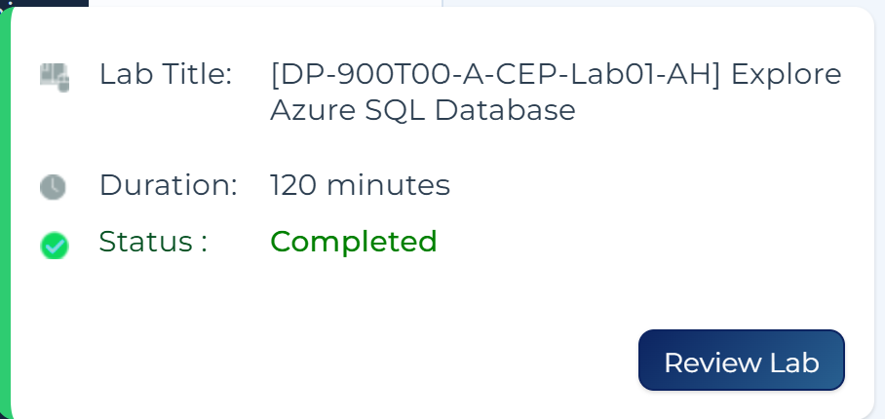

Day 3: Task 2 – Lab 2

Please complete the lab - Your tutor will guide you

Completed lab | 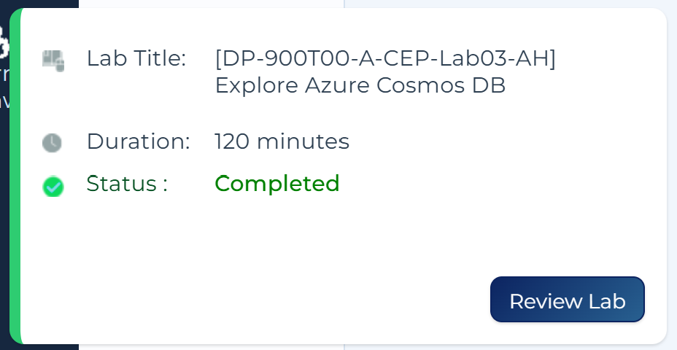  `

Day 3: Task 3 – Lab 3

Please complete the lab - Your tutor will guide you

Completed lab | 

Day 3: Task 4 – Lab 4

Please complete the lab – Your Tutor will guide you.

Completed lab | 

Day 4: Task 1 – Lab 6

Complete Lab – Your tutor will guide you.

Result

Day 4: Task 2

1. Scenario Background
"Paws & Whiskers" is a growing pet shop that aims to improve its business by analysing sales, customer information, and inventory data. Currently, the data is collected manually or stored in spreadsheets. Management is interested in transitioning to Microsoft Azure to streamline data storage, analysis, and reporting, enabling them to make data-driven decisions.

2. Data Laws and Regulations
Identify and explain the data laws and regulations relevant to handling customer data within the proposal. Ensure you cover the following points:
- GDPR Compliance: Highlight the importance of adhering to the General Data Protection Regulation (GDPR), particularly as it relates to storing and processing customer information.
- Data Protection Act (DPA) 2018: Outline how the DPA 2018 may affect the way "Paws & Whiskers" collects and stores data, ensuring compliance with UK laws on data privacy.
- Other Industry Standards: Research any additional data protection standards or regulations that may apply to pet shop data, particularly if they involve sensitive or payment information.

3. Azure Service Recommendations
Recommend Microsoft Azure services that would suit the company’s data analysis needs and explain why these services are suitable. Your recommendations should include:
- Data Storage: Identify suitable storage options, such as Azure Blob Storage or Azure SQL Database, and discuss the benefits of each for storing large datasets, including inventory, sales transactions, and customer details.
- Data Analysis Tools: Recommend tools such as Azure Machine Learning for customer behaviour analysis or Azure Synapse Analytics for analysing sales trends.
- Data Integration and Automation: Explain how services like Azure Data Factory could automate data collection and integration processes, improving efficiency.

4. Data Types and Data Modelling
Define the types of data "Paws & Whiskers" will need to work with and describe your approach to data modelling:
- Data Categories: Identify key data types, such as customer demographics, transaction history, pet inventory, and product categories.
- Data Modelling Approach: Outline how you would structure this data using a relational model or a data warehouse approach, considering factors like tables, entities, relationships, and primary keys.

5. Data Storage Formats and Structures in Azure
Discuss how you would store data within Azure and the formats you would recommend:
- Data Formats: Specify recommended formats (e.g., CSV for raw data imports, JSON for structured data, Parquet for analytics) and explain why these formats are suitable for specific data types.
- Data Security and Encryption: Include recommendations for securing data using Azure’s built-in encryption features and access controls to ensure compliance with data privacy regulations.

6. Additional Considerations
Provide any other considerations that might enhance data handling and efficiency in Azure, such as:
- Backup and Disaster Recovery: Outline a backup plan using Azure Backup or Azure Site Recovery to safeguard against data loss.
- Data Visualisation: Discuss the potential use of Power BI within Azure for creating dashboards that provide management with real-time insights into sales and customer trends.
- Future Scalability: Comment on how Azure services can scale as the business grows, accommodating larger datasets and more complex analyses.

Submission Guidelines:
- Structure: Ensure your report is well-organised, with sections for each task (e.g., Data Laws, Azure Services, Data Types, etc.).
- Formatting: Include headings, bullet points where appropriate, and any visuals or diagrams that support your explanations.
- References: Cite any resources or regulations referenced in the report.
- Length: Aim for 1500-2000 words.
- Undertake your fact-checking and cite your sources

Data Strategy Proposal:
Migrating Paws & Whiskers to Microsoft Azure

Executive Summary:

Paws & Whiskers are trying to move away from manual, spreadsheet-based record keeping and onto Microsoft Azure. It covers the data laws we need to follow, the Azure services best suited to our sales, customer and inventory data, cost efficiency, how that data should be structured and stored, and how we can keep it secure and back it up. The aim is to give management a clear, practical starting point for making data driven decisions as the business grows.

Currently issue and Benefits after switching:

  - Paws & Whiskers records sales, customer details and stock levels manually or across separate spreadsheets. This works while the business is small, but it makes it hard to spot trends, easy to introduce errors through manual entry, and risky if a laptop is lost or a file is accidentally deleted, since there's no automatic backup. Moving to Azure would bring all of this data into one secure, searchable system, and free up staff time currently spent on manual record keeping.

- Data Laws and Regulations:

Before processing any customer data, we need to first know Data Laws and Regulation, we need to be sure we are meeting all legal obligation, Three areas are particularly relevant to Paws & Whiskers.

2.1 GDPR Compliance
The UK GDPR sets out the core rules for how personal data must be handled. For Paws & Whiskers, this means customer details such as names, addresses, email addresses and pet ownership records must be collected for a clear reason, kept accurate, stored securely, and only kept for as long as needed.

2.2 Data Protection Act (DPA) 2018
The DPA 2018 is the law that works alongside UK GDPR. It affects how we collect and store data in a few practical ways, we should only ask customers for the data we actually need (for example, we don't need a customer's date of birth to sell them dog food), we must have a lawful reason for holding each piece of data, and we need to be able to show, if asked, that we are following the rules. This means our Azure setup should include clear records of what data we hold, why we hold it, and who can access it.

2.3 Other Industry Standards
Because Paws & Whiskers takes card payments, we also fall under the Payment Card Industry Data Security Standard (PCI DSS). This is not a government law but a requirement set by card providers (Visa, Mastercard, etc.) for any business that stores, processes or transmits card details. It means we should never store full card numbers ourselves, and any payment processing built into our Azure system should go through a PCI-compliant payment provider rather than handling raw card data directly. Getting this wrong risks fines and losing the ability to take card payments at all.
- Azure Service Recommendations

The table below summarises the Azure services I'd recommend, grouped by what they're used for.
Service | What it does | Why it suits Paws & Whiskers
Azure SQL Database | A fully managed relational database for structured data with clear rows, columns and relationships. | Ideal for sales transactions, customer records and stock levels, where we need accuracy, fast lookups and the ability to run reports.
Azure Blob Storage | Low-cost object storage for large amounts of unstructured data such as files, images and backups. | Good for storing product photos, scanned receipts, supplier documents, and archived data we don't need to query directly.
Azure Synapse Analytics | An analytics platform that brings together data warehousing and big data processing in one place, and connects directly to Power BI. | Useful once we have enough sales history to spot trends, e.g. which products sell best by season, without needing separate tools.
Azure Machine Learning | A platform for building and running predictive models. | Could later help predict customer buying patterns (e.g. when a customer is likely to reorder pet food) or forecast stock needs.
Azure Data Factory | A tool for automating the collection, movement and transformation of data between sources, without writing complex code. | Would let us automatically pull sales data from tills and spreadsheets into Azure each night, instead of manual entry.

- Data Types and Data Modelling

4.1 Data Categories
• Customer demographics: names, addresses, contact details, purchase history, and loyalty scheme information.
• Transaction history: what was bought, when, quantity, price and payment method.
• Pet inventory: current stock levels, reorder points, and supplier details.
• Product categories: groupings such as food, toys, grooming, accessories and healthcare products

4.2 Data Modelling Approach
A customers table might hold CustomerID (primary key), Name, Email and Address; a Products table might hold ProductID (primary key), ProductName, Category and StockLevel; and an Orders table would hold OrderID (primary key), CustomerID (foreign key), OrderDate and TotalPrice. A separate OrderLines table would then link each Order to the specific Products bought and their quantities. Structuring the data this way keeps information consistent (a customer's address only needs updating in one place) and stops us from duplicating the same details across thousands of order records.

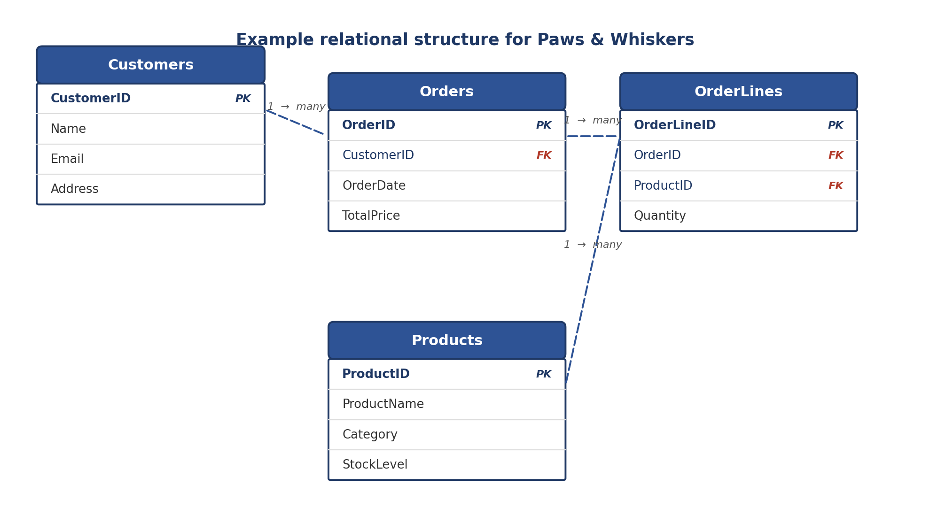

it would be worth introducing a data warehouse approach alongside the operational database, using Azure Synapse Analytics. This keeps day to day transaction processing fast and separate from the larger, historical queries used for reporting

- Data Storage Formats and Structures in Azure

5.1 Data Formats
Format | Best suited for | Reason
CSV | Raw data imports, e.g. exporting till or spreadsheet data into Azure. | Simple, human-readable, and works with virtually every tool, including Excel.
JSON | Structured data with nested details, e.g. an order containing multiple products. | Handles hierarchical data well and is the standard format for APIs and web-based systems.
Parquet | Large-scale analytics once historical sales data builds up. | Compresses data heavily and reads much faster than CSV/JSON for the column-based queries analytics tools run.

5.2 Data Security and Encryption
- Encryption by default: all data in Azure SQL Database and Blob Storage is encrypted automatically, both at rest and while moving between systems.
- Access controls: Azure Active Directory should be used to control exactly who can view or edit customer and payment-related data, following the principle that staff only get access to what they need.
- Auditing: Azure's activity logs let us track who accessed what data and when, which supports our accountability duties under the DPA 2018.
Together, these controls mean that even if a device is lost or an account is compromised, customer and payment data stays protected, and we have a clear record to show regulators we are meeting our GDPR and DPA 2018 obligations if we're ever asked.
- Additional Considerations

6.1 Backup and Disaster Recovery
I'd recommend Azure Backup for scheduled, automatic backups of our databases and files, and Azure Site Recovery to keep the business running if there's a major outage, by replicating our systems to a second location. Together, these reduce the risk of losing sales or customer records to hardware failure, accidental deletion, or a cyberattack.

6.2 Data Visualisation
Power BI, which connects directly to Azure Synapse Analytics, would let management view live dashboards covering sales performance, best selling products and customer trends, without needing to ask for a manual report each time. This turns raw data into something the whole management team can act on quickly.

6.3 Future Scalability
One of the main advantages of Azure over our current spreadsheet system is that it grows with us. As Paws & Whiskers opens more branches or takes on more customers, storage and processing power can be increased with a few clicks rather than buying new hardware, and we only pay for what we use. This means the same setup proposed here can support the business whether we stay a single shop or expand into a small chain.

6.4 Recommended Next Steps
- set up an Azure SQL Database and migrate our current customer, product and sales spreadsheets into properly structured tables.
- configure Azure Backup so we have automatic, scheduled backups from day one, rather than relying on manual saves.
- build a simple Power BI dashboard covering our most-used reports, such as weekly sales and low-stock alerts, so management sees an early return on the move.
- review access permissions with Azure Active Directory so only the right staff can see customer and payment-related data.
I'd be happy to put together a rough cost estimate and timeline for this migration if it would help with the next stage of planning.

Sources
- ICO — Data protection principles: https://ico.org.uk/for-organisations/uk-gdpr-guidance-and-resources/data-protection-principles/
- GOV.UK — Data protection: https://www.gov.uk/data-protection
- PCI Security Standards Council — PCI DSS: https://www.pcisecuritystandards.org/standards/pci-dss/
- Microsoft Learn — Azure Blob Storage overview: https://learn.microsoft.com/en-us/azure/storage/blobs/storage-blobs-overview
- Microsoft Learn — What is Azure SQL Database: https://learn.microsoft.com/en-us/azure/azure-sql/database/sql-database-paas-overview
- Microsoft Learn — What is Azure Synapse Analytics: https://learn.microsoft.com/en-us/azure/synapse-analytics/overview-what-is
- Microsoft Learn — What is Azure Machine Learning: https://learn.microsoft.com/en-us/azure/machine-learning/overview-what-is-azure-machine-learning
- Microsoft Learn — What is Azure Data Factory: https://learn.microsoft.com/en-us/azure/data-factory/introduction
- Microsoft Learn — Azure Backup overview: https://learn.microsoft.com/en-us/azure/backup/backup-overview
- Microsoft Learn — Azure Site Recovery overview: https://learn.microsoft.com/en-us/azure/site-recovery/site-recovery-overview
- Dremio — Evolving the Data Lake: CSV/JSON to Parquet: https://www.dremio.com/blog/evolving-the-data-lake-from-csv-json-to-parquet-to-apache-iceberg/

Course Notes

It is recommended to take notes from the course, use the space below to do so, or use the revision guide shared with the class:

Additional Information

We have included a range of additional links to further resources and information that you may find useful, these can be found within your revision guide.

END OF WORKBOOK

Please check through your work thoroughly before submitting and update the table of contents if required.

Please send your completed work booklet to your trainer.

